**ABSTRACT CLASS**

**Presented By**

**Saipreetham V**

**ABSTRACT CLASSES AND METHODS**

**Abstract class**

A class that is declared as abstract is known as **abstract class**. It can have abstract and non-abstract methods (method with body). It needs to be extended and its method imple- mented. It cannot be instantiated.

Syntax:

abstract class classname

{

}

# Abstract method

**A method that is declared as abstract and does not have implementation** is known as abstract method. The method body will be defined by its subclass.

**Abstract method can never be final and static**. Any class that extends an abstract class must implement all the abstract methods declared by the super class.

Note:

A normal class (non-abstract class) cannot have abstract methods.

Features of Abstract Class

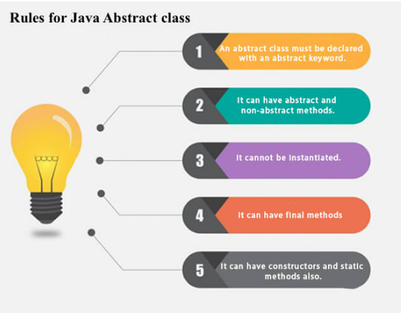

**Example**

Making coffee with a coffee machine is a good example of abstraction. You need to know how to use your coffee machine to make coffee. You need to provide water and coffee beans, switch it on and select the kind of coffee you want to get.



**Questions on Abstraction**

**1) Why final and abstract cannot be used at a time?**

**Ans:**

Because, final and abstract are totally opposite in nature. A final class or method can not be modified further where as abstract class or method must be modified further. “final” keyword is used to denote that a class or method does not need further improvements. “abstract” keyword is used to denote that a class or method needs further improvements.

**2) Can we declare abstract methods as private? Justify your answer?**

**Ans:**

No. Abstract methods cannot be private. If abstract methods are allowed to be private, then they will not be inherited to sub class and will not get enhanced.

**3) How to achieve or implement Abstraction in Java?**

**Ans:**

There are two ways to implement abstraction in java. They are as follows:

a) Abstract class (0 to 100%)  
b) Interface (100%)

**4)What is the difference between abstract class and concrete class?**

**Ans:**

There are mainly two differences between an abstract class and concrete class. They are:

a) We cannot create an object of abstract class. Only objects of its non-abstract (or concrete) sub classes can be created.

b) It can have zero or more abstract methods that are not allowed in a non-abstract class (concrete class).

**5) Can we make an abstract class without abstract keyword?**

**Ans:**

No, a class must be declared with abstract keyword to make an abstract class.